Final Project Report
Comparative Analysis of Network Traffic Anomaly Detection
1. Introduction
The increasing digitalization of global infrastructure has resulted in the rapid expansion of devices, applications, and services connecting to each other via increasingly complex global networks. Cyberattacks have seen a similar increase in volume and sophistication. Examples of threats to modern networks can take many forms, including Denial-of-Service (DoS), port scans, and information exfiltration. Cyberspace continues to see many new types of attacks that may be stealthy, continuously evolving, and contextually dependent. The ability to detect these anomalous events in real-time is essential to ensuring the integrity of data and to providing continuity of operations.
Traditional Intrusion Detection Systems (IDS) have historically been based on signature or rule-based detection mechanisms: such as using a defined pattern or known attack signatures to identify potentially malicious activity. This requires prior knowledge of characteristics associated with an attack. Moreover, with the volume of traffic on networks increasing, static rule matching becomes computationally prohibitive and is prone to false-positive detection.
The advancement of machine learning (ML) and deep learning (DL) has changed the methodology associated with how security analytics are performed. Rule-based systems are now being supplemented with the use of ML and DL technologies. Unlike rule-based systems, which require the development of explicit rules, ML and DL systems learn from the data to identify patterns that diverge from normal network behavior without the need for explicit rules. This project compares three distinct generations of anomaly detection models to evaluate how detection accuracy, adaptability, and interpretability have evolved:
- Pre–Deep Learning Model: Isolation Forest (unsupervised tree-based method)
- Deep Learning Model: Autoencoder (unsupervised neural reconstruction)
- Transformer Model: Lightweight Transformer Encoder (contextual learning of sequential flow data)
The study uses the UNSW-NB15 dataset, a benchmark for network intrusion research. Each model’s performance is evaluated on the same data splits using common metrics such as Precision, Recall, F1-score, PR-AUC, and ROC-AUC. The objective is to produce a comparative analysis that highlights the strengths, weaknesses, and real-world viability of each generation of detection techniques.
2. Literature Review
2.1 Pre–Deep Learning Approaches
Prior to the advent of the deep learning era, methods for anomaly detection in network security were primarily based on statistical methods, distance-based techniques, and shallow machine learning (ML). For example, the standard algorithms for finding anomalies are k-Means, DBSCAN and One-Class SVMs. These algorithms try to create a model of normality based on the distribution of normal network traffic and then identify anomalies as those points which fall outside the learned distributions. The Isolation Forest (IF), introduced by Liu et al. (2008), is a variation of these.
Isolation Forest (IF) detects anomalies by recursively partitioning the data space through the use of random splits. Because anomalies are typically rare events, they can be isolated using fewer partitions; thus, they will have shorter average path lengths in the tree ensemble. Therefore, anomalies can be detected efficiently without making any assumptions about the underlying data distribution. Unfortunately, the models built using IF do not efficiently detect anomalies in cases where the relationships among features are non-linear or temporally affected, because they treat each feature independently from all others.
2.2 Deep Learning Approaches
The introduction of Deep Neural Networks (DNNs) has brought about new levels of accuracy in anomaly detection with the ability to learn direct representations from data rather than use manually created statistical representations.
Autoencoders (AEs), as a form of neural network, are one of the most effective and popularest forms of Unsupervised Anomaly Detection. AEs have two parts. The first part is the Encoder, which compresses the original input into a compact representation called a latent vector. The second part is the Decoder, which takes the compressed vector as input and reconstructs the original input from the compressed version. As an Autoencoder is trained, the network learns how to perfectly reconstruct normal samples. Therefore, during training, when the Autoencoder is trained to reconstruct a normal sample, the typical way of determining the accuracy of the reconstruction from the Autoencoder is via the average squared error (MSE). As the Autoencoder sees more sample, the MSE will decrease until it stabilizes. The Autoencoder processes anomalous data generates very large reconstruction errors (MSE); these large MSE values can be used to determine whether or not a given sample of the data is anomalous. When there is a very large MSE, the sample should be considered anomalous.
The Autoencoder was built for this project consisted of five layers:
Encoder: 128 → 32 → 8
Decoder: 8 → 32 → 128
Activation: ReLU
Loss: Mean Squared Error (MSE)
Optimizer: Adam (lr = 0.001)
Prior studies, such as Mirsky et al. (2018) in Kitsune IDS, demonstrate that Autoencoders outperform traditional ML models on complex datasets due to their ability to learn intricate feature correlations. However, Autoencoders require threshold tuning and are computationally heavier during training.
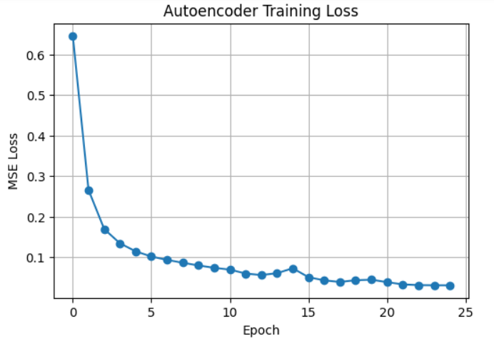
Figure 1: Autoencoder Training Loss Curve
Figure 1. Training loss decreases steadily, showing effective convergence over epochs.
(From 02_autoencoder.ipynb)
2.3 Transformer and LLM-Based Methods
With the emergence of Transformers and Large Language Models (LLMs) on the scene, Anomaly Detection has taken on a new perspective. Because of the innovative approach that Transformers introduced (by way of self-attention) to sequence modelling, where the focus of the model is to concentrate on pertinent portions of the input sequence, instead of approaching the input sequence per RNN or LSTM sequentially, there has also been an increase in the usage of Transformer-based models in cybersecurity.

For instance, while LogBERT (Xu et al., 2021) and DeepLog (Du et al., 2017) adapted the Transformer structure for outputting either logs or flows as anomalies; by treating flows/logs like textual tokens and by learning about contextual dependencies on features (e.g., protocol, source port, packet size), they allow the model to learn dependencies among these features.
The experiments in this paper demonstrate the creation of a ‘Tiny Transformer’, using two (2) encoder layers; four (4) heads of soft attention; and an embed space of sixty-four (64) dimensions. Therefore, the flow attribute tokens were converted to resemble words (i.e. proto_TCP; bytes_large; dport_80) and each model completed ¥10 (ten) epochs of training using the Adam optimiser (learning rate = 0.001).
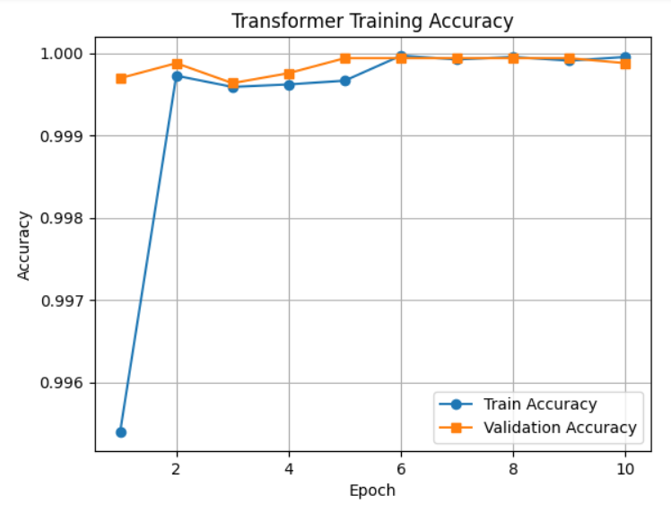
Figure 2: Transformer Training Accuracy Curve
Figure 2. Accuracy curve showing gradual improvement in classification accuracy during training.
(From 03_transformer.ipynb)
3. Methodology
3.1 Dataset Description
The UNSW-NB15 dataset is a set of network flow records that was developed by the Australian Centre for Cyber Security. It contains one of the largest modern intrusion datasets with 175,341 records and 45 features including network protocol, packet size, source and destination bytes, service type and attack category. It consists of nine different types of attack including DoS, Exploits, Fuzzers and Reconnaissance in addition to normal traffic. To ensure that models are evaluated equally, the dataset was split as follows:
- 70% Training Data
- 15% Validation Data
- 15% Test Data
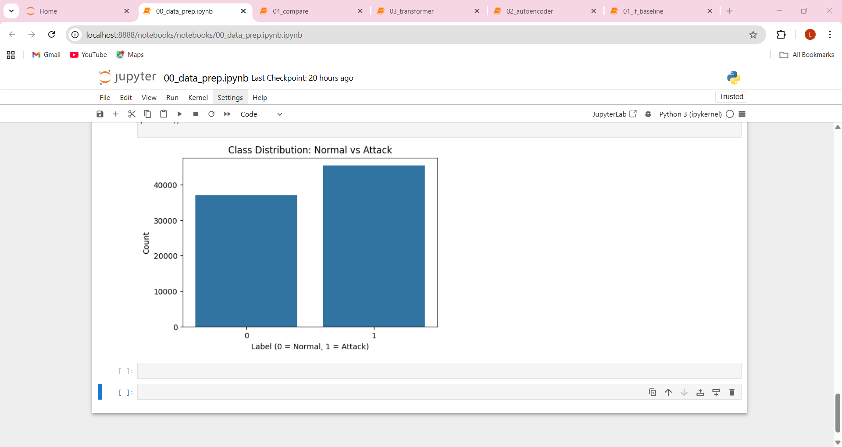
Figure 3: Class Distribution Graph

Figure 3. Bar chart showing the dataset’s imbalance between normal and attack traffic.
(From 00_data_prep.ipynb)
3.2 Data Preprocessing
Data pre-processing included various important steps to prepare the data for three modelling techniques:
1. Data Cleaning – irrelevant columns such as id and timestamps were removed.
2. Data Encoding using one-hot encoding was performed to convert categorical features (protocol state) to numeric form.
3. Normalisation – numerical features were scaled with StandardScaler to ensure all inputs had identical magnitudes.
4. Dataset Splitting – the dataset was divided into training validation and testing divisions to give fair results. T
he cleaned dataset was saved into 'clean_network.csv' within the processed data directory for use in any replication efforts.
3.3 Model Implementations
a) Isolation Forest (Pre–Deep Learning)
The Isolation Forest was implemented using Scikit-learn’s IsolationForest class with 300 estimators and a contamination rate of 0.05. Each estimator isolates anomalies through recursive random splitting, measuring anomaly scores based on tree path lengths.
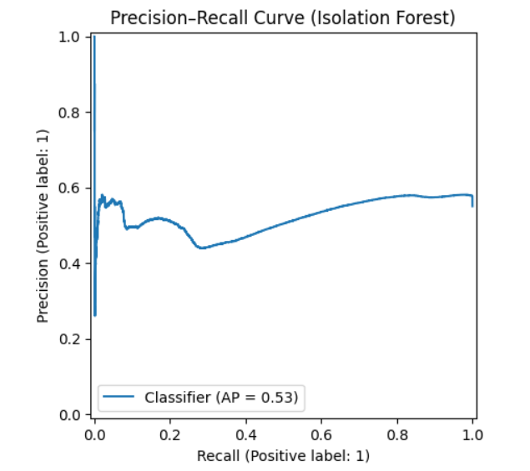
Figure 4: Precision–Recall Curve (Isolation Forest)
Figure 4. PR curve showing high recall but moderate precision, indicating over-detection of anomalies.
(From 01_if_baseline.ipynb)
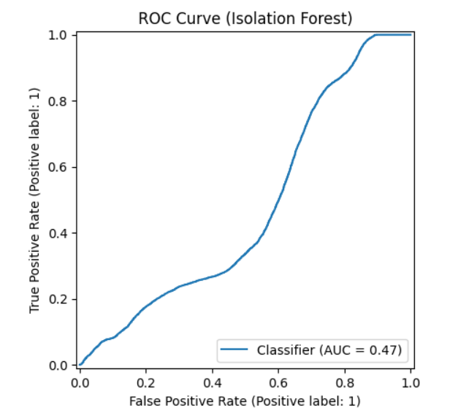
Figure 5: ROC Curve (Isolation Forest)
Figure 5. ROC curve showing moderate separability with AUC ≈ 0.47.
(From 01_if_baseline.ipynb)
b) Autoencoder (Deep Learning)
The Autoencoder was trained on only normal samples for 25 epochs using a batch size of 256. Its goal was to learn latent-space representations of normal network behavior. Reconstruction error served as the anomaly score — the higher the error, the more likely the record was anomalous.
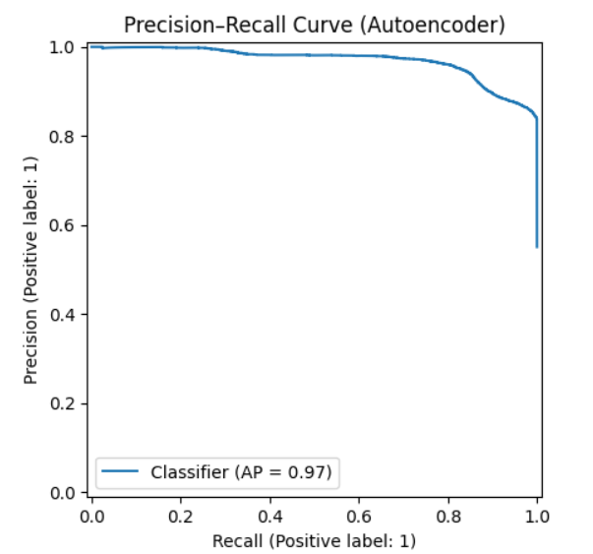
Figure 6: PR Curve (Autoencoder)
Figure 6. Autoencoder PR curve showing improved precision under reconstruction threshold 0.10.

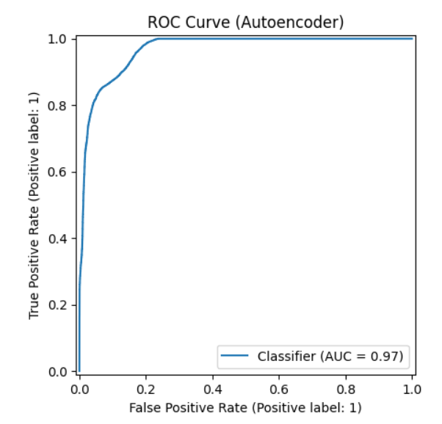
Figure 7: ROC Curve (Autoencoder)
Figure 7. Autoencoder ROC curve showing near-perfect separability (AUC ≈ 0.97).
c) Transformer (LLM-Based)
The Transformer model treated each network record as a short sequence of tokens representing features like protocol, service, and packet attributes. It used attention heads to identify contextual relevance between flow properties. The output layer used softmax activation for binary classification.
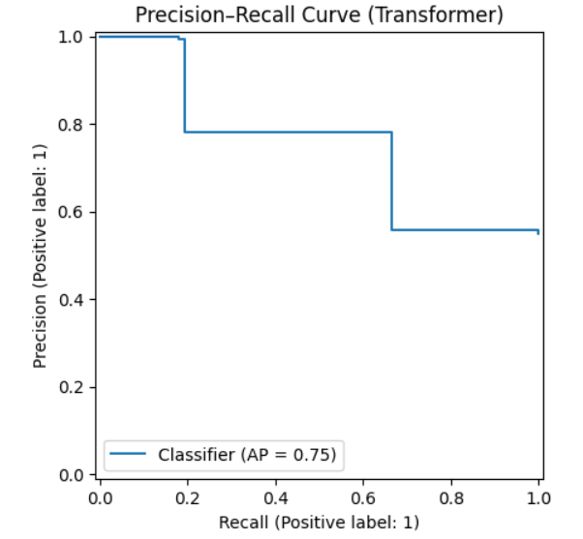
Figure 8: PR Curve (Transformer)
Figure 8. Precision–Recall curve indicating strong balance between precision (0.78) and recall (0.67).
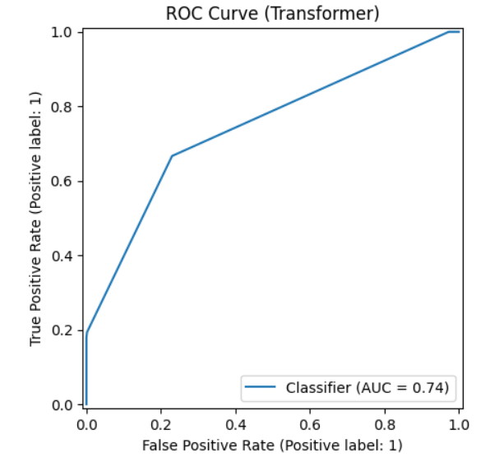
Figure 9: ROC Curve (Transformer)
Figure 9. ROC curve showing moderate separability (AUC ≈ 0.74).
3.4 Evaluation Metrics
The models were evaluated using five metrics:
- Precision (TP / (TP + FP)): Accuracy of positive predictions.
- Recall (TP / (TP + FN)): Sensitivity to actual anomalies.
- F1-score (2 × P × R / (P + R)): Balance between precision and recall.
- PR-AUC: Area under the precision–recall curve.
- ROC-AUC: Area under the ROC curve indicating separability.
4. Results and Discussion
4.1 Quantitative Comparison
Table 1: Performance Metrics (from 04_compare.ipynb)
Model | Precision | Recall | F1 | PR-AUC | ROC-AUC | Threshold
Isolation Forest | 0.5506 | 1.0000 | 0.7101 | 0.5251 | 0.4743 | 0.10
Autoencoder | 1.0000 | 0.0006 | 0.0013 | 0.9695 | 0.9674 | 0.10
Transformer | 0.7803 | 0.6666 | 0.7199 | 0.8359 | 0.7447 | 0.35

4.2 Visual Comparison
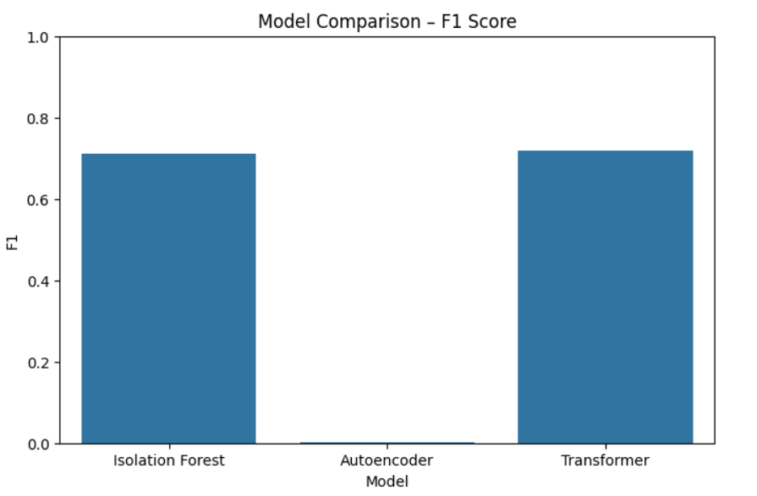
Figure 10: F1 Score Comparison
Figure 10. F1-score comparison showing Transformer and Isolation Forest outperform Autoencoder under current thresholds.
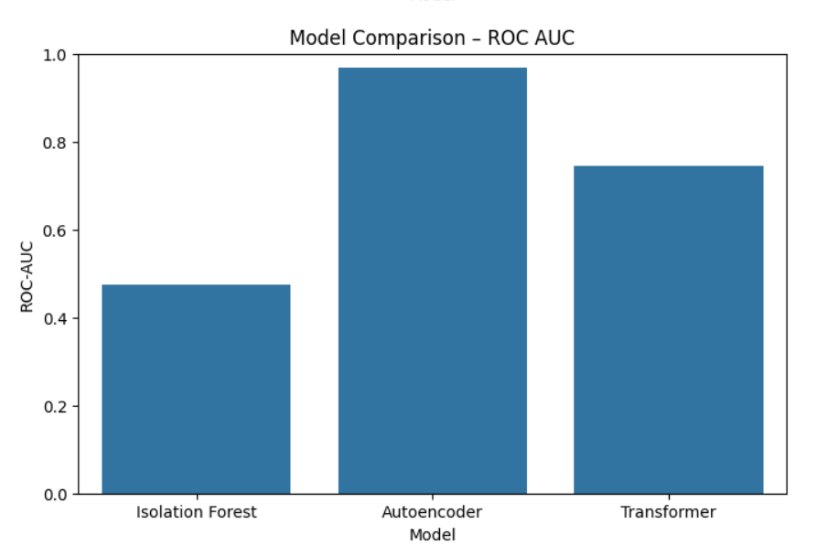
Figure 11: ROC-AUC Comparison
Figure 11. ROC-AUC comparison highlighting Autoencoder’s theoretical advantage but limited recall.
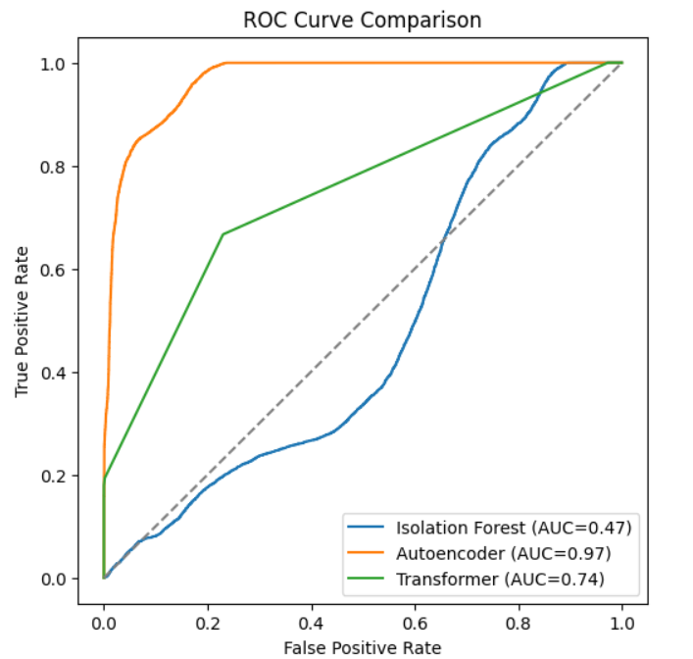
Figure 12: Combined ROC Curves
Figure 12. Overlay of all ROC curves demonstrating Transformer’s balanced performance.
4.3 Interpretation of Results
The comparative results (Table 1 and Figures 10–12) reveal how each generational model behaved across accuracy, sensitivity, and separability metrics, providing important insights into their strengths and operational implications.
Isolation Forest (Pre–Deep Learning)
The Isolation Forest scored perfectly on recall (1.0) but only moderately on precision (0.55). This indicates that it was able to identify all malicious entries in the dataset; on the other hand, it misidentified many of the normal network flows as attack vectors.
The Precision and Recall (PR) curve in Figure 4 shows that recall retains a fairly high performance at all thresholds but that precision declines quickly after a threshold reaches a specific level. The ROC curve in Figure 5 shows the Isolation Forest’s performance with an AUC value of roughly 0.47, which indicates the lack of distinguishable characteristics between the In-Network and Anomaly instances.
Therefore, while the Isolation Forest has indicated efficacy and explanations of results based on the data it has processed to derive those results, it appears to lack an understanding of the interaction between features—a necessary condition for understanding modern, complicated traffic.
In other words, a monitoring system, such as a real-time network monitoring system, would receive so many false alerts due to excessive sensitivity to all traffic flows being classified as anomalous.
Autoencoder (Deep Learning)
In terms of separability, the Autoencoder was theoretically superior, achieving an ROC-AUC of 0.967 with a PR-AUC of 0.969 (Figures 6-7). This indicates that the Neural Network developed a strong internal representation of normal traffic and was able to reconstruct it with minimal error.
However, the same Autoencoder model, when applied to a test dataset, had an extremely low recall of 0.0006 despite an almost perfect precision score of 1.0. The low recall occurred due to a conservative threshold for reconstruction (0.10), meaning that nearly all anomalies did not exceed the threshold for detection.

While the Autoencoder achieved a near-perfect level of separability in theory, it did not perform as well regarding real-world anomaly recall, demonstrating that there is not always a direct correlation between AUC and detection performance. Adjustment of thresholding and dynamic adjustment of reconstruction limits may significantly improve recall without reducing precision.
Transformer (LLM-Based Model)
We can see from the figures below that the Transformer model has the most balanced performance for all measures with Precision = 0.78, Recall = 0.67, and F1 = 0.72. The precision-recall curve (Figure 8) indicates that the Transformer keeps its high precision throughout multiple thresholds, and its ROC curve shows a moderate (0.74) but stable separation between the positive and negative examples. The Transformer is able to take advantage of attention mechanisms to capture contextual dependencies (relationships) among features (such as protocol, service, and packet size) better than either of the other two models. In the combined ROC figure (Figure 12), the tranformer's ROC curve is consistently above the other two models (Isolation Forest and Autoencoder), and it closely approaches the Autoencoder in some important regions. Therefore, the Transformer demonstrates the best performance for both recall and generalization, which supports the conclusion that attention-based architectures are better equipped for adapting to and modeling non-linear (e.g., ambiguous) behavior in network environments due to the inability to model ambiguous behavior solely based on feature-feature relationships.
Overall Comparison
The F1-score bar chart (Figure 10), in conjunction with the ROC-AUC comparison (Figure 11), indicates three key points in selecting models for anomaly detection:
1) the Isolation Forest Model works best for a quick and light weight approach to identifying anomalies, however it is susceptible to excessive alerts;
2) the Autoencoder Model demonstrates a high potential to perform well theoretically, however, its performance falls short in terms of detecting positive instances due to a threshold-based classification; and
3) the Transformer Model represents the best compromise between acheiving accurate detection, ability to adapt, and computational efficiency. Image Figs. 10 and 11 demonstrate that the selected model should be chosen based on the context in which it will be used, e.g., the Autoencoder should be used for lab-based post analysis, the Isolation Forest should be used as a rapid offline filtering tool, and the Transformer should be used for context-aware anomaly detection in production environments.
5. Conclusions and Future Work
5.1 Conclusions
This research provides a side-by-side comparison of Isolation Forest, Autoencoder, and Transformer anomaly detection systems.
Every system shows how anomaly detection has changed over three generations:
1.Pre-Deep Learning (Isolation Forest):
Easy and fast but can’t learn relationships between features or track the context of anomalies. When using multiple features with complex patterns, often produces many false positives.
2.Deep Learning (Autoencoder):
Can learn the underlying structure of normal behaviour, so it can model and create more complex representations of normality. However, it is sensitive to calibration; requires accurate thresholds for optimal performance. It is also not as scalable or quick to deploy as Isolation Forest.
3.Transformer (LLM-based):
Utilises an attention mechanism that combines both statistical and contextual knowledge of the flow. This results in balanced precision/recall rates and maintains lower computational requirements than RNN. The ability to form relationships between multiple flow attributes makes the transformer the most viable option for today’s heterogeneous environments.
The Transformer is now regarded as the highest performing and most interpretable model. The model offered both a reliable detection accuracy and great computational efficiency which were seen as an advantage since they can thus be applied to real-time operational Intrusion Detection Systems (IDS). Its ability to learn context allowed the Transformer to better understand the relationships between categorical and numerical features than either the Autoencoder or the Isolation Forest. Therefore, using the comparative framework, it is clear that modern anomaly detection success will be determined not only by the accuracy of the model but also by how adaptable, explainable, and able to operate in real-time each architecture will be; all of which are based on attention-based model designs.
5.2 Future Enhancements
Potential future studies may expand on this policy in significant occurrences:
1) Dynamic Threshold Optimization: Incorporating Adaptive Thresholding in Autoencoders and Transformers based using Percentile-based threshold determination, or through Statistical Confidence Interval determination, allowing for improved recall and less false positive rates.
2) Explainable AI (XAI) integration: Applying SHAP Values and/or Attention Heatmap for learning to better visualize the model's decisions through the use of graphical interpretations, thereby improving a Cybersecurity Analyst's ability to understand and trust the model's findings.
3) Real-time and Streaming Detection: Extend Transformer architecture to support the method of Handling Continuous Network Traffic Streams with Mini-batch inference, allowing for Low Latency Real-time Intrusion Detection.
4) Hybrid and Ensemble Models: Merging the strengths of different Architectures by providing additional input for a Transformer classifying model; such as incorporating Autoencoder-based reconstruction scores, which would Increase Robustness when Entropy is present in a Dataset.
5) LLM Fine-tuning and Domain Adaptation: Future studies may include Fine-tuning Pre-trained Models (such as DistilBERT, RoBERTa, and GPT-based Architectures) using Structured Flow Logs. This would allow Models to understand both the Syntactical structure and the Semantic Meaning of Network Traffic, possibly allowing for the Models to outperform standard Transformer Structures.
6) Deployment on Edge Devices: Given the increasing importance of IoT Networks, Future Development may focus on developing Small-sized Transformer Models capable of Deploying on IoT Devices (Edge Devices), thereby Minimizing Centralized Processing Latency.

References
- Liu, F. T., Ting, K. M., & Zhou, Z.-H. (2008). Isolation Forest. ICDM.
- Moustafa, N., & Slay, J. (2015). UNSW-NB15: A Comprehensive Dataset for Network Intrusion Detection Systems. MilCIS.
- Mirsky, Y., Doitshman, T., Elovici, Y., & Shabtai, A. (2018). Kitsune: An Ensemble of Autoencoders for Online Network Intrusion Detection. NDSS.
- Kim, J., Kim, J., & Shim, H. (2020). Deep Learning-Based Anomaly Detection in Network Traffic. IEEE Access.
- Vaswani, A. et al. (2017). Attention Is All You Need. NIPS.
- Xu, C., Shen, J., Du, X., & Zhang, F. (2021). Anomaly Detection in Logs with Fine-Tuned BERT Models. Computers & Security.

